NADCP-FMD Collaborating Centre 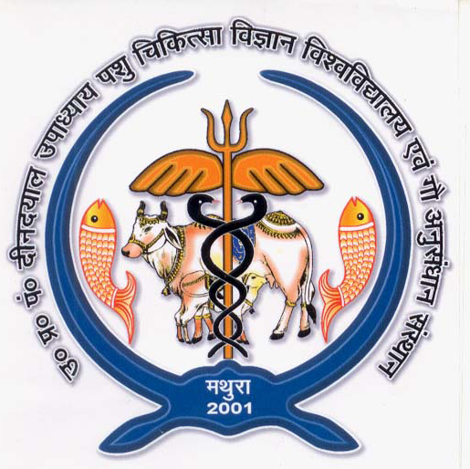
U.P. Pt. Deen Dayal Upadhyaya Pashu Chikitsa Vigyan Vishwavidyalaya
Evam Go-Anusandhan Sansthan, (DUVASU), Mathura -281 001

Notification for engagement of Young Professional-II (YP-II) in the in NADCP on FMD for surveillance diagnosis and epidemiology of FMD in the Uttar Pradesh

Applications are invited for walk-in-interview for engagement of one (01) Young Professional-II and one (01) Laboratory Assistant in the DAHD funded NADCP project.

Place of posting:, NADCP-FMD Project, Collaborating centre, COVSc & AH, DUVASU, Mathura (U.P)

Eligibility criteria
Essential:
Young Professional-II: Master degree in the discipline of Virology/ Microbiology/ Biotechnology/ Biochemistry/ Life Sciences or graduate degree holder in Veterinary science.
Laboratory Assistant: Bachelor degree in Science or 3 year Diploma in relevant subjects.
Desirable: -
- Young Professional-II – Candidates with knowledge and experience in ELISA technique will be preferred.
- Laboratory Assistant – Basic computation skills like MS office, data analysis and compilation.

Emoluments:

Young Professional-II – Rs 35,000 (Consolidated)

Laboratory Assistant – Rs 20,000+ HRA
Age Limit:
- Upper Age Limit is 45 years on the date of interview (5 years relaxation for SC/ST/women candidates and 3 years for OBC candidates as on date of interview). Along with the application, Bio-Data, SC/ST/OBC certificate (wherever applicable) duly attested is to be submitted.

Interested candidates can attend the walk-in-interview in the Committee Room, University Administrative Block, DUVASU, Mathura (UP)-281001 on August 18, 2021 at 10.00 AM.

Terms & Conditions:
  - The appointments will be on contractual basis and co-terminus with the project, and the incumbent shall not have any claim for regular appointment under the Project/ University / ICAR.
  - The candidate must bring one set of their complete bio data with self-attested copies of the testimonials and age proof with a passport size photograph along with all original certificates of all required certificates from matriculation onwards and experience certificate in original (if any) with them.
  - Concealing of facts or canvassing in any form shall lead to disqualification of the candidature or termination even afterappointment.
  - The period of appointment of will be Young Professional-II and Laboratory Assistant initially for a period up to FY 2021-22 i.e. March 31, 2022 and is likely to be extended further on yearly basis subject to satisfactory performance of the candidate.
  - The appointments may be terminated at any time without notice or assigning any reason thereof. The Young Professional-II and Laboratory Assistant may also leave the assignment, on their own volition, by giving one month notice. At the end of the contract period, they will have no right to claim any employment or engagement in theProject / University / ICAR.
  - No TA/DA will be paid to the applicants for appearing ininterview.
  - Candidates fulfilling the essential qualification only need to attend the walk-in Interview.
  - Candidates desirous of attending the walk in interview are requested to report at the required venue at 10 am.
  - The selected candidates will be required to undergo medical examinationas per the rules for ensuring their physical fitness beforeappointment.
  - The candidates are required to submit the application as per the format annexed (ANNEXURE-I) dulysigned.

Annexure: I Application Form for Engagement of Young Professional-II and Laboratory Assistant under the NADCP-FMD, DUVASU, Mathura-281001
1. | Post applied for |  | Photo to be pasted here
2. | Full Name (in Block letters) |  | Photo to be pasted here
3. | Father’s / Husband Name |  | Photo to be pasted here
4. | Gender [✓] | Male / Female | Photo to be pasted here
5. | Date of Birth |  | Photo to be pasted here
6. | Age as on 10.08.2021
7. | Marital Status
8. | Mobile Number
9. | E-Mail Address
10. | Correspondence Address(with pin Code)
11. | Permanent Address
12. | Whether belongs to SC/ST/OBC/General
13. | Subject specialization :

14. | S.  No | Name of degree |  | Board/ University |  | Year of passing |  | Duration of course  (in Years) |  | Max. Marks |  |  | Marks Obtained | Marks/ Percentage  /CGPA
 | 1. | 10th Class or equivalent
 | 2. | 10+2/Higher Secondary  equivalent
 | 3. | Bachelor’s Degree
 | 4. | Master’s Degree
 | 5. | Ph. D.
 | 6. | Others (Specify)
15. | Are you NET Qualified? |  |  | Yes/No  IF yes, which of the following. (✓)  - ASRB-NET  - CSIR-NET  - UGC-NET  - MHRD-GATE  - DBT- Biotechnology Eligibility Test  - Test Conducted in Bioinformatics by Bioinformatics NationalConsortium  - ICMR- JRF Entrance Exam  - ICAR JRF EntranceExam  - Dop –GPAT  - DAE-JEST & JGEEBILS,NBHM
16. | Work experience :
 | S. No |  | Designation |  | Name of employer |  |  |  | Period |  |  | No. of years/ month
 |  |  |  |  |  |  |  |  | From |  | To
 | 1.
 | 2.
 | 3.
17. | Publications (Number only):  - PublishedpapersinJournals  - Chapters published inBook:  - Books Published:
18. | Present employment details
19. | Additional Information, if any

The information given above by me is true to the best of my Knowledge and belief. If any information is being found false, my candidature/services, if selected, may be terminated without anynotice.

Signature:
Date:

